MES’ ABASAHEB GARWARE COLLEGE
KARVE ROAD, PUNE - 411004

A PROJECT ON
ATTENDANCE USING FACE RECOGNITION SYSTEM

SUBMITTED BY
Shaunak Suryawanshi – 16861
Satej Wani – 16838
Deeya Nikam – 16835

Under the guidance of
Mrs. Priyanka Borase

M.Sc. (Computer Applications) Semester- 2
Year 2025-26

Index
Sr. No. | Content | Page No.
1. | Acknowledgement | 2
2. | Introduction | 3
3. | Existing System | 6
4. | Scope of the system | 7
5. | Feature of the system | 8
6. | System Requirement  - Hardware  - Software | 9
7. | Feasibility study  - Technical Feasibility  - Economical Feasibility  - Operational Feasibility | 10
8. | Analysis and Design  - ER Diagram  - UML Diagram | 11
9. | Data Dictionary | 14
10. | Input-Output Screen | 15
11. | Limitations/Drawbacks | 17
12. | Future Enhancement | 18
13. | Bibliography | 20

- ACKNOWLEDGEMENT

We would like to express our sincere gratitude to our project guide, Mrs. Priyanka Borase, for her continuous support, guidance, and invaluable insights throughout the development of this project. Her expertise and encouragement have been instrumental in shaping our work.
We are also deeply thankful to our Head of Department, Mrs. Chitra Nagarkar, for providing us with the necessary resources and motivation to successfully complete this project. Her leadership and support have played a significant role in our academic journey.
Lastly, we extend our appreciation to our institution, faculty members, and peers for their encouragement and constructive feedback, which have helped us improve and refine our project.
Thank you.

- INTRODUCTION

The “Face Recognition Attendance System” project stands as a transformative endeavor, poised at the intersection of technological innovation and educational enhancement. In response to the longstanding challenges faced by educational institutions in managing attendance, this project endeavors to revolutionize traditional methods by harnessing the power of advanced facial recognition technology and machine learning algorithms.
Delving into the intricacies of attendance management reveals a landscape fraught with inefficiencies and shortcomings. From the cumbersome manual processes of paper based attendance sheets to the limitations of electronic systems, educators have long grappled with the complexities of accurately tracking student attendance. These challenges are exacerbated in large classrooms or lecture halls, where the sheer volume of students makes manual data entry a time-consuming and error-prone task.
Recognizing the imperative for a more streamlined and reliable solution, the project embarks on a mission to reimagine attendance management from the ground up. At its heart lies the Haar Cascade Classifier, a sophisticated algorithm renowned for its prowess in facial recognition tasks. By leveraging this technology, coupled with a robust backend infrastructure, the project aims to create an automated attendance capture system that transcends the limitations of traditional methods.
The significance of this endeavor extends far beyond the realm of attendance tracking. At its core, the project represents a convergence of cutting-edge technology and pedagogical innovation, with the potential to reshape the educational landscape. By automating the attendance capture process, educators are liberated from the burdensome task of manual data entry, allowing them to redirect their time and energy towards more impactful endeavors such as student engagement and academic support. Furthermore, the project’s dedication to accuracy and reliability serves as a cornerstone in ensuring the integrity of attendance records within educational institutions. By implementing advanced facial recognition technology and stringent verification protocols, the system mitigates the potential for errors and fraudulent activities, thereby safeguarding the authenticity of attendance data.

In an educational landscape where data-driven decision-making is increasingly paramount, the system’s ability to provide reliable attendance records empowers educators with a solid foundation for informed analysis and strategic planning. Armed with accurate attendance data, institutions can identify trends and patterns in student attendance, enabling them to tailor interventions and support mechanisms to address specific needs effectively.
The real-time insights offered by the system serve as a powerful tool for proactive intervention and support. By promptly identifying instances of absenteeism or irregular attendance patterns, educators can intervene swiftly to provide necessary assistance and resources to students in need. Whether through targeted interventions, counseling sessions, or additional academic support, the system enables institutions to foster a supportive environment conducive to student success.
Moreover, the system’s capacity for real-time monitoring allows educators to track the effectiveness of their interventions and initiatives over time. By correlating attendance data with academic performance metrics, institutions can gain valuable insights into the impact of various interventions on student outcomes. This data-driven approach enables educators to refine and optimize their strategies, ensuring that resources are allocated effectively to support student success.
In essence, the project’s commitment to accuracy, reliability, and real-time insights serves as a catalyst for enhancing student engagement, retention, and success within educational institutions. By leveraging technology to streamline attendance management processes and empower educators with actionable data, the system contributes to the overarching goal of creating a supportive and conducive learning environment for all students.
In addition to its immediate benefits, the project lays the groundwork for future innovation and expansion. By designing a scalable and adaptable solution, the project ensures that educational institutions can seamlessly integrate the system into their existing workflows and infrastructure. Furthermore, ongoing research and development efforts promise to enhance the system’s capabilities and extend its reach to new domains and applications.
In summary, the “Face Recognition Attendance System” project represents a pivotal step towards reimagining attendance management in educational institutions. Through its innovative approach, unwavering commitment to excellence, and dedication to empowering educators, the project aims to usher in a new era of efficiency, effectiveness, and student success.

2.1 Motivation:
The motivation behind this project stems from the longstanding challenges faced by educational institutions in managing attendance effectively. Traditional methods, such as manual paper-based systems or basic electronic methods, are not only time consuming but also prone to inaccuracies and fraud. With classrooms becoming increasingly larger, accurately recording the attendance of numerous students becomes a tedious task for teachers. Furthermore, the lack of real-time insights or analytics hampers institutions’ ability to monitor attendance trends effectively.

2.2 Problem Definition:
The primary problem addressed by this project is the inefficiency and unreliability inherent in traditional attendance management methods. Manual processes, such as paper-based systems or simple electronic methods, are susceptible to errors and inaccuracies, leading to unreliable attendance records. Moreover, these methods lack the capability to provide real-time insights into attendance patterns, hampering institutions’ ability to monitor attendance effectively. The project seeks to mitigate these challenges by introducing an automated attendance management system that harnesses the power of facial recognition technology. By automating the attendance recording process, the system aims to enhance accuracy, efficiency, and real-time monitoring capabilities, thereby revolutionizing attendance management practices in educational institutions.

2.3 Objectives:
1. Enhance efficiency by automating attendance recording processes.
2. Ensure accuracy and reliability through advanced facial recognition technology.
3. Implement robust security measures to protect attendance data.
4. Design a user-friendly system that seamlessly integrates into existing institutional workflows.
3. EXISTING SYSTEM

The traditional attendance systems include:
- Manual Attendance Register:
  - Involves marking attendance on paper.
  - Highly time-consuming and prone to human errors.
  - Easy to manipulate or forge.
- Biometric Systems (Fingerprint Scanners):
  - Require physical contact for authentication.
  - Can be affected by dirt, cuts, or moisture on fingers.
  - Maintenance issues due to hardware wear and tear.
- RFID Card Systems:
  - Attendance is marked by scanning an ID card.
  - Cards can be lost, stolen, or used by someone else.
  - Requires regular maintenance of RFID readers and cards.
- Barcode/QR Code Scanners:
  - Users scan their assigned codes to mark attendance.
  - Easily reproducible; low security.
  - Requires users to carry and maintain their codes.
- Mobile App Check-ins or GPS Tracking:
  - Can be manipulated using location spoofing apps.
  - Not reliable in poor GPS connectivity zones.
  - Raises privacy concerns among users.

All these systems have limitations in terms of security, user-friendliness, and scalability. They often require physical interaction, making them less effective in post-pandemic or contactless environments. The need for a more robust, contactless, and intelligent system led to the development of facial recognition-based attendance systems.

4. SCOPE OF THE SYSTEM

The face recognition attendance system is designed to:
- Record attendance of individuals automatically using facial recognition.
- Store attendance data in a secure database.
- Generate reports for specific timeframes.
- Integrate with institutional ERP systems for real-time updates.
- Be scalable for various organizational sizes.
- Support multiple departments or classes within a single institution.
- Be deployed across distributed campuses or remote office locations.
- Allow both on-site and remote attendance capturing.
- Provide administrative insights and analytics dashboards for attendance trends.
- Improve security through tamper-proof attendance records.
- Enable seamless integration with payroll and HR systems in corporate setup

5. FEATURES

5.1 Face Recognition
- Identifies and matches faces from a dataset using deep learning-based facial recognition.
- Supports real-time and batch processing of face images.

5.2 Face Similarity Scoring
- Computes similarity between two or more faces based on extracted facial features.
- Uses cosine similarity or Euclidean distance for measuring facial resemblance.

5.3 Recommendation Engine
- Suggests faces based on user preferences, predefined aesthetic metrics, or machine learning models.
- Offers filtering based on age, gender, and other attributes.

5.4 Machine Learning Integration
- Employs deep learning models like Convolutional Neural Networks (CNNs) and Siamese Networks for feature extraction.
- Utilizes pre-trained models like FaceNet, Dlib, and OpenCV.

5.5 Real-time Processing
- Capable of processing and recommending faces in real-time using optimized face detection and recognition techniques.
- Supports live camera feeds and video streams.

- SYSTEM ARCHITECTURE

6.1 Components
- Frontend: Web interface for uploading images, viewing recommendations, and user interaction.
- Backend: RESTful API handling image processing, model execution, and database interactions.
- Database: Stores user profiles, facial embeddings, and recommendation history.
- AI Model: Deep learning model trained on facial datasets for extracting embeddings and generating recommendations.
6.2 Technology Stack
- Frontend: HTML / CSS/ JS for dynamic UI.
- Backend: Python-based Flask/Django/FastAPI for handling API requests.
- Database: PostgreSQL / MongoDB for storing user profiles and embeddings.
- AI Model: TensorFlow / PyTorch utilizing FaceNet, Dlib, or OpenCV for facial recognition.
6.3 Hardware:
- Webcam or camera
- Computer with minimum i5 processor
- 8GB RAM
- 500GB Hard Disk
6.4 Software:
- Operating System: Windows
- Python
- OpenCV
- MongoDB
- Flask (for web interface)

7. FEASIBILITY STUDY

7.1 Technical Feasibility:
- Utilizes mature and reliable technologies like OpenCV and Python that are widely supported and documented.
- Compatible with various hardware and software platforms, making it highly adaptable.
- Scalable architecture allows deployment across multiple branches or departments.
- Integration with machine learning libraries enables continual improvement in accuracy.
7.2 Economic Feasibility:
- Significantly reduces the cost compared to traditional biometric devices which require expensive hardware.
- Development cost is minimal due to the use of open-source tools and libraries.
- Lower maintenance cost since the system requires only standard computing equipment.
- Automation leads to long-term savings by reducing administrative overhead.
7.3 Operational Feasibility:
- Easy-to-use system with a minimal learning curve for staff and administrators.
- Can be deployed in educational institutions, businesses, and remote settings.
- Supports automation of routine tasks like report generation and data backup.
- Enhances accountability and transparency in attendance monitoring.
- Reduces chances of proxy attendance and manual errors.

  - ANALYSIS AND DESIGN

- Image Upload: The user uploads an image through the frontend interface.
- Preprocessing: The system normalizes, resizes, and detects faces in the uploaded image using MTCNN or Haar cascades.
- Feature Extraction: A deep learning model extracts facial embeddings from detected faces.
- Similarity Computation: The extracted embeddings are compared with stored dataset embeddings using cosine similarity.
- Recommendation Generation: The system retrieves and ranks the most similar faces.
- Result Display: The recommended faces are displayed on the frontend for user interaction.

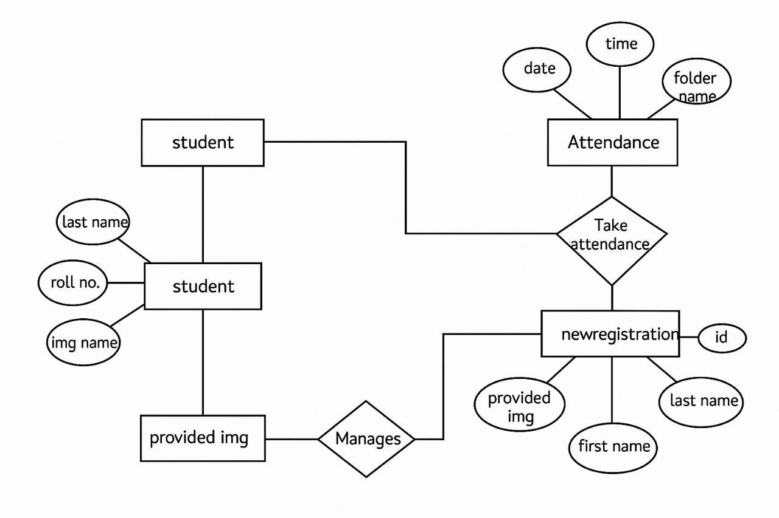
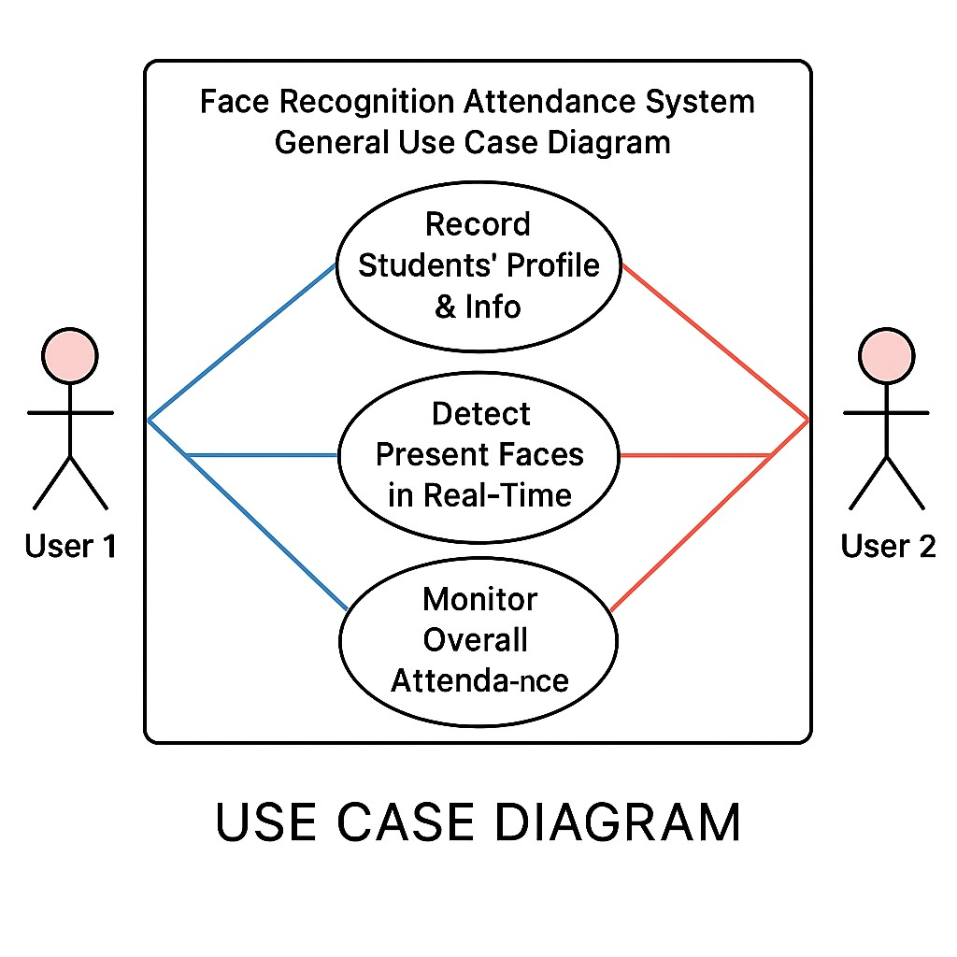

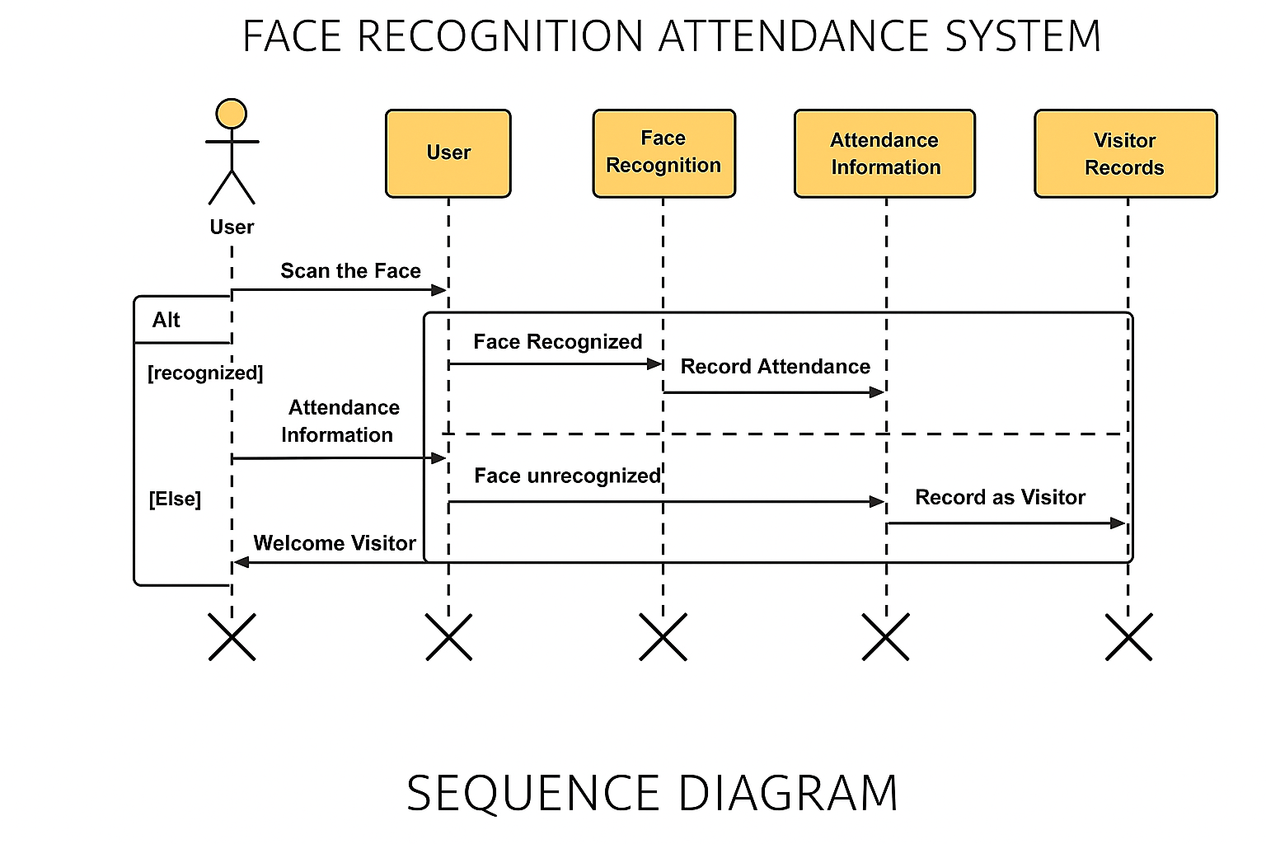

8.1 Model Training
8.1.1 Dataset
- Uses a large dataset of human faces such as CelebA, LFW (Labeled Faces in the Wild), and custom datasets.
- Data augmentation techniques are applied for improved model generalization.
8.1.2 Preprocessing
- Image normalization, resizing, and face alignment to ensure consistency in training.
- Histogram Equalization for enhancing contrast and reducing noise.
8.1.3 Training Algorithm
- Convolutional Neural Networks (CNNs) are used for feature extraction.
- Triplet Loss Function improves the ability of the model to differentiate between similar and dissimilar faces.
8.1.4 Evaluation Metrics
- Accuracy, Precision, Recall, and F1-score are measured to assess model performance.
- ROC Curve and AUC Score are analyzed for model validation.

  - DATA DICTIONARY

Field Name | Data Type | Description
user_id | Integer | Unique ID of the user
name | String | Name of the user
face_encoding | Binary | Encoded facial data
date | Date | Attendance date
time | Time | Attendance time
status | String | Present/Absent

Endpoint | Method | Description
/upload | POST | Uploads an image for analysis and recognition
/recommend | GET | Returns face recommendations based on similarity
/train | POST | Triggers model training using new dataset
/health | GET | Checks system health and availability

  - INPUT AND OUTPUT SCREENS



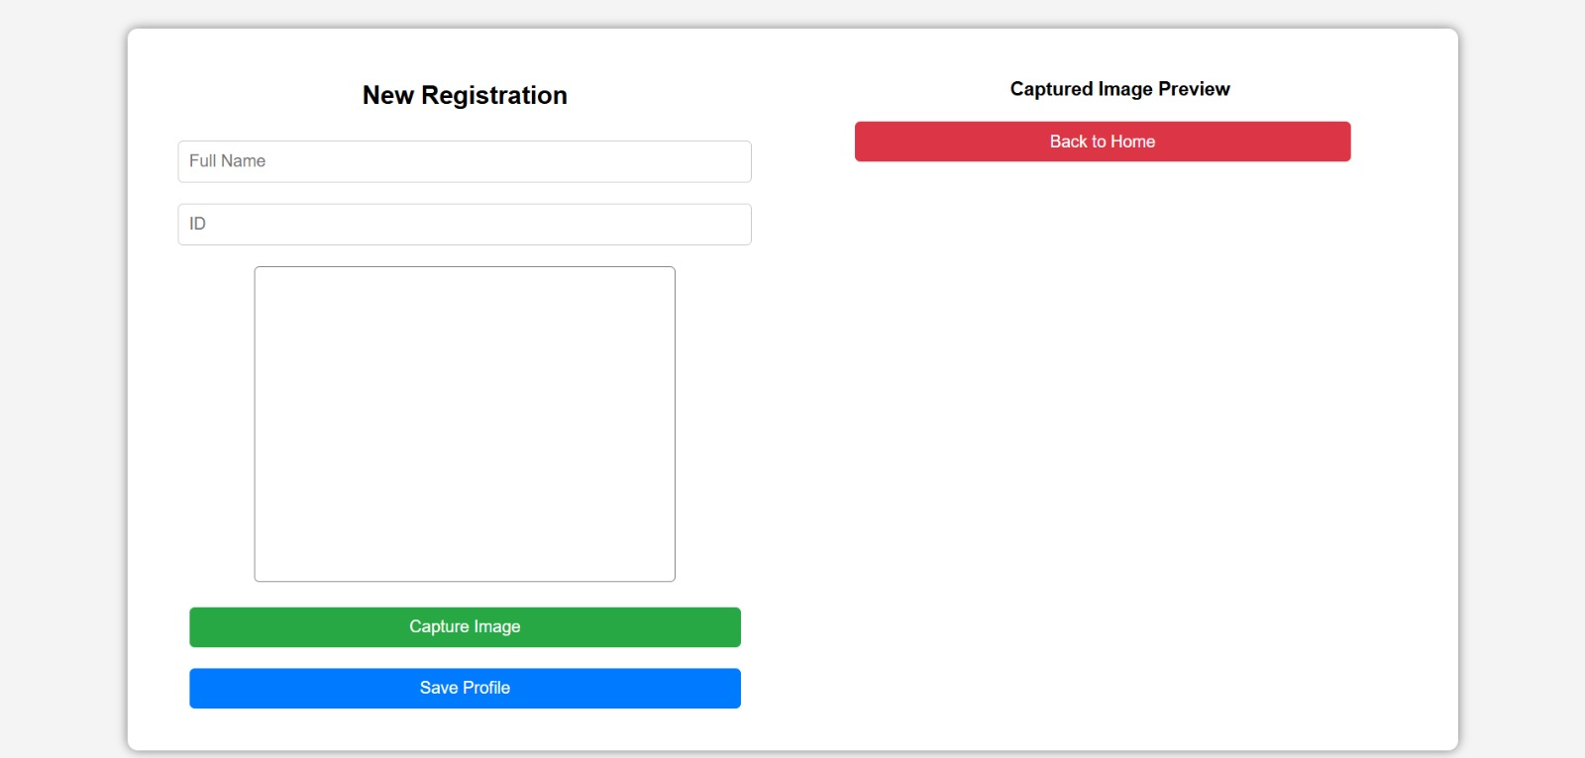
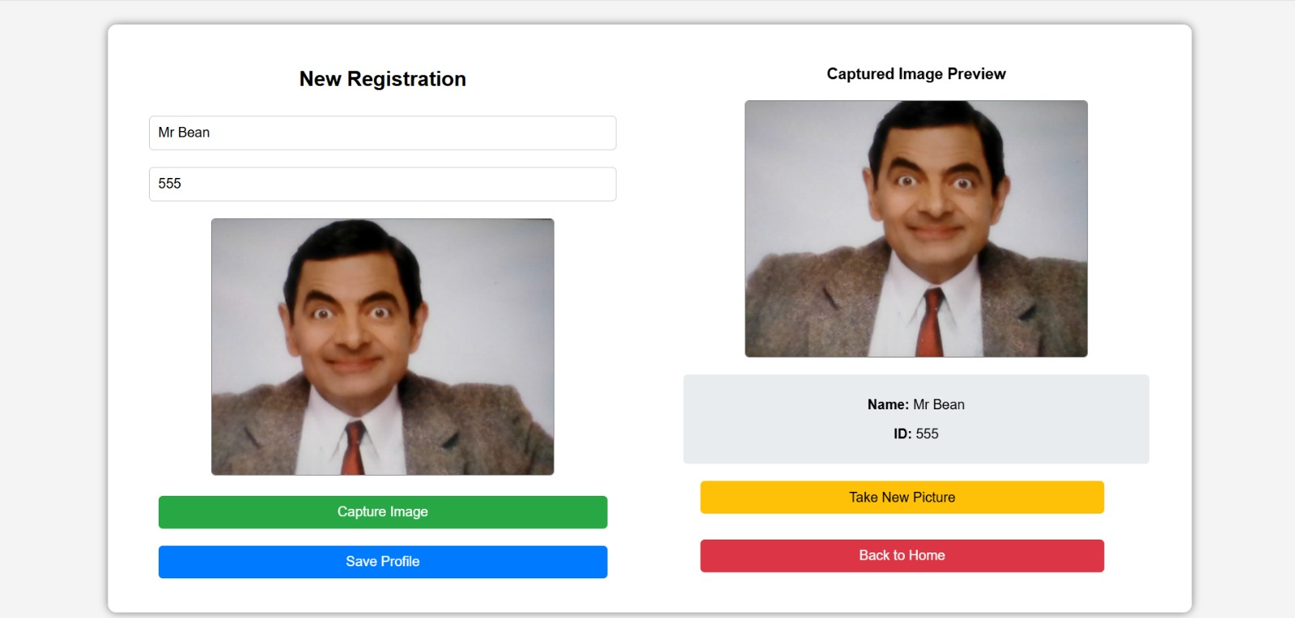

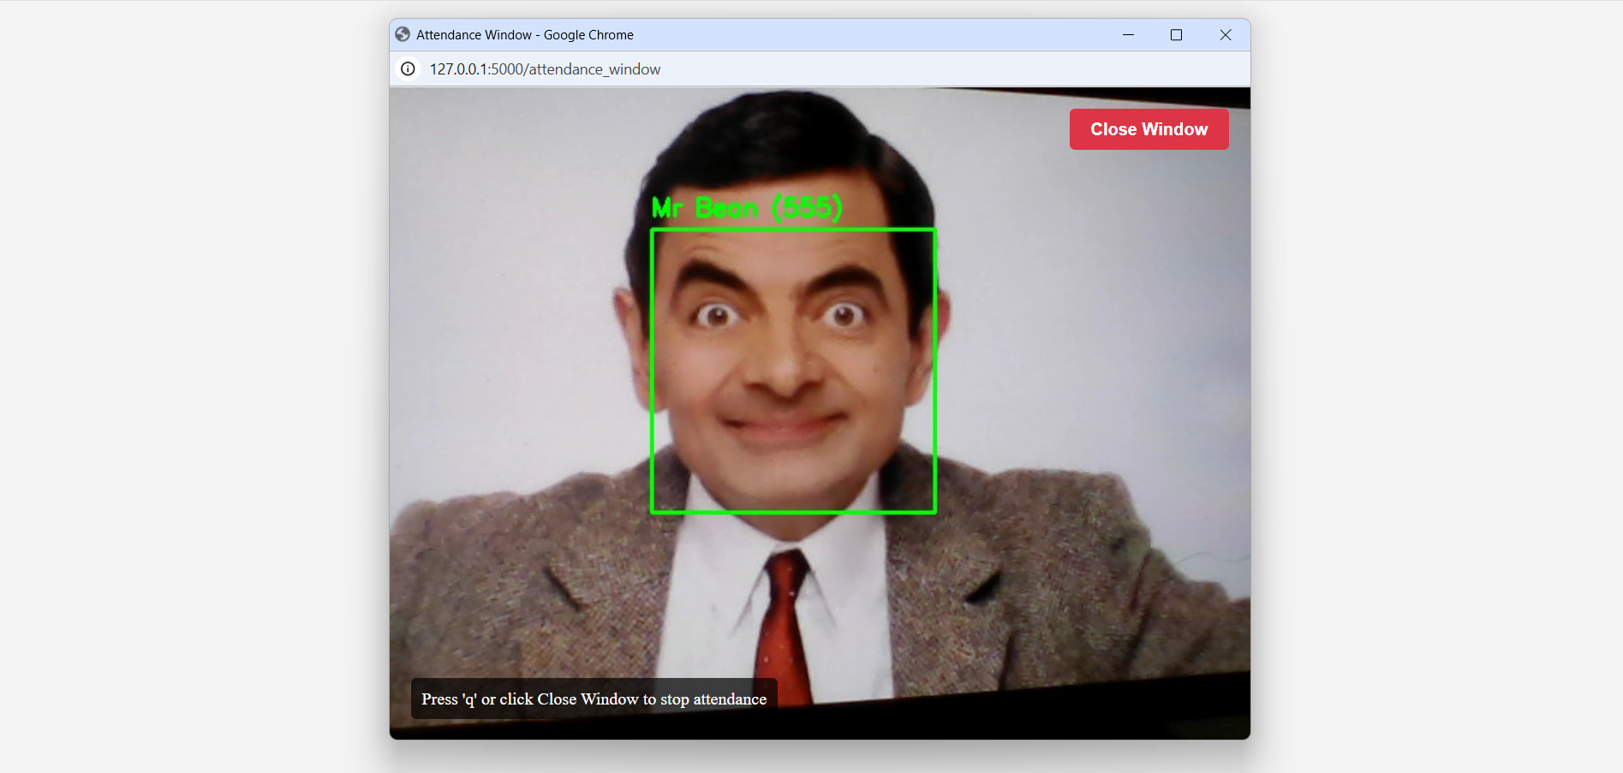

11. LIMITATIONS/DRAWBACKS

- Lighting Conditions: Inconsistent lighting such as low light, strong shadows, or glare can significantly reduce recognition accuracy.
- Facial Obstructions: Items like face masks, scarves, sunglasses, or headgear can obscure facial features, making it difficult for the system to authenticate the user correctly.
- Camera Quality Dependency: The effectiveness of recognition depends heavily on the resolution and frame rate of the camera used. Low-end webcams may not capture sufficient detail.
- Network Dependency: A reliable internet connection is crucial for cloud-based processing or remote access to the attendance database. Offline environments may cause delays or data sync issues.
- Infrastructure Costs: Institutions or businesses without existing infrastructure may face initial costs related to setting up high-definition cameras and compatible computing systems.
- Data Privacy Concerns: Storing biometric data raises serious privacy and ethical concerns. Institutions must comply with data protection laws such as GDPR or local regulations to ensure user consent and secure storage.
- System Bias: Certain facial recognition algorithms may have bias toward specific demographic groups, resulting in unequal accuracy and performance.
- Environmental Limitations: Outdoor environments or crowded areas may affect performance due to unpredictable variables such as movement, weather conditions, or background noise.
- Scalability Challenges: In large-scale implementations, maintaining performance and managing high volumes of facial data can become challenging without proper optimization.
- False Positives/Negatives: The system may incorrectly mark attendance due to false recognition (recognizing the wrong person) or fail to recognize a legitimate user, leading to errors in attendance records.

12. FUTURE ENHANCEMENT
12.1 Future Work:
Despite the achievements of our project, there are several areas for future exploration and enhancement. One potential avenue for future research is the further refinement of face detection and recognition algorithms. Exploring advanced machine learning techniques, such as deep learning approaches, may lead to more sophisticated and adaptive recognition capabilities, particularly in challenging conditions.
Integrating multi-modal biometrics, including fingerprint or iris recognition, could enhance the system's security and reliability. Additionally, optimizing the system for real-time performance and improving the user interface could facilitate easier adoption by educators and administrators.
Overall, the field of Automatic Face Recognition Attendance Management Systems presents vast opportunities for future research and development. By addressing these key areas of improvement and exploration, we can contribute to the ongoing evolution and advancement of attendance tracking technology, ultimately benefiting educators, students, and educational institutions as a whole.

AR/VR Integration
- Integrating augmented reality for real-time virtual try-ons.
Improved AI Models
- Experimenting with Swin Transformers and Vision Transformers (ViTs) for higher accuracy.
Multi-modal Recommendations
- Combining facial features with other attributes such as voice and posture for more comprehensive recommendations.

12.2 Conclusion
In summation, our project represents a significant leap forward in the realm of attendance management systems with the creation of an Automatic Face Recognition Attendance Management System. By harnessing the power of sophisticated technologies such as the open CV and frontal facial recognition algorithm, we have successfully showcased the system's robust capabilities in detecting and recognizing individual students' faces from video frames. This achievement underscores a notable advancement in attendance tracking technology, particularly within educational institutions, where accurate and efficient attendance recording is paramount.
Throughout the intricate process of implementation, we encountered and navigated through a myriad of challenges, ranging from variations in lighting conditions to facial occlusions. However, through our relentless pursuit of innovation and problem-solving, we seamlessly integrated advanced image processing techniques into the system. These techniques not only bolstered the system's accuracy and reliability but also ensured consistent and precise attendance recording across diverse environmental conditions. Despite the remarkable strides we've made, our project acknowledges that there is always room for enhancement and refinement. Looking ahead, future iterations of the system will undoubtedly focus on fine-tuning the underlying algorithms to further elevate the system's performance in terms of speed and accuracy in face detection. Moreover, we recognize the importance of optimizing both hardware and software configurations to maximize the system's efficiency and efficacy.

13. BIBLIOGRAPHY

- OpenCV Documentation: https://docs.opencv.org/
- Python Official Website: https://www.python.org/
- Flask Framework: https://flask.palletsprojects.com/
- Face Recognition Libraries: https://github.com/ageitgey/face_recognition

